

Firmware High Level Design
for
Low power modes
of HL78xx

Document #: | 41112313
Legacy #: | N/A
Revision: | R01.04
Document Type: | Design Document
Customer Name: | N/A
Author: | Christophe Flechelle & José Lourenço
Author Document Creation Site: | ILM
Document Location: | FileHold
Date: | 2018/06/08

Document History

Rev  XX.YY | Date  YYYY/MM/DD | Updates | Author
01.00 | 2018/01/03 | Creation | CFL
01.01 | 2018/03/14 | Updates (AT+KSLEEP…) | JLO
01.02 | 2018/04/06 | Low Power diagram added, updates done following new Altair information | JLO
01.03 | 2018/05/23 | Modifications on AT+KSLEEP AT command after new Altair’s information on Low Power modes | JLO
01.04 | 2018/06/08 | Add new LITE_HIBERNATE Mode + minor updates | CFL & JLO

Contents
1 Introduction 5
1.1 Purpose 5
1.2 Scope 5
1.3 References 5
1.4 Glossary of terms 5
2 System Overview 5
2.1 Environment 5
2.2 Platform 5
2.3 Requirements 5
2.4 Altair Reference Design 6
3 System Design Architecture 7
3.1 Module Power states 7
3.1.1 Power Down state (OFF) 7
3.1.2 Deep Hibernate (0,1,2) 8
3.1.3 Deep Sleep 9
3.1.4 Active 10
3.2 Cellular Modes 10
3.2.1 System scenario: 11
3.3 System power saving mode configuration 11
3.4 HL78xx Hardware design 12
3.4.1 Schematics DV3 12
3.4.2 DTR signal 12
3.5 HL78xx Sleep modes 13
3.5.1 Low power modes always forbidden. 13
4 Low power mode management with AT+KSLEEP command. 13
4.1 AT+KSLEEP syntax 13
4.1.1 Hardware management: KSLEEP=0,<level>. 14
4.1.2 Standalone management: KSLEEP=1. 15
4.1.3 Sleep mode forbidden: KSLEEP=2 15
4.1.4 NVM 15
5 PSM 16
6 eDRX 16
7 Power OFF 16
Power modes summary for Software phase 1 17
8 Power mode transitions diagram (NOT UP TO DATE) 19
9 Annexes 20
Extract of an Altair’s email for the explanation of the Low power modes vote mechanism (Available only in the June 2018 Altair’s software delivery). 20

Introduction

Purpose
This document contains the High-Level Design for the applications component of the HL78xx_1250 firmware for the low power mode feature.

Scope
This document defines how Sierra Wireless will manage low power mode regarding Altair’s possibilities

References

Ref. # | Document title | Doc. #
[R-1] | AT command set for User Equipment | 3GPP TS 27.007 version 14.2.0 Release 14

Glossary of terms

Term | Definition
LTE | Long Term Evolution
PSM | Power Saving Mode
eDRX | Extended Discontinuous Reception

System Overview

Environment
HL78xx is an Essential Airprime module based on the CF3 form-factor.
This module embeds the Altair 1250 chipset.

Platform
HL78xx product.

Requirements
HL78xx products must follow as much as possible sleep mode management of other HL series products configured by the +KSLEEP AT command; i.e. 3 modes:
- Sleep mode always forbidden.
- Sleep mode forbidden when DTR is active. When DTR is inactive, sleep mode is allowed. CTS goes inactive when DTR is inactive.
- Standalone sleep mode: module decides by itself when it can go in sleep mode from the UART point of view (nothing to send on UART, nothing received on RX for a while). Sleep mode state is indicated by the CTS going to inactive.
Module should be always using the lowest power mode possible.

Altair Reference Design
Altair reference design is a module with almost all the modem functionalities implemented and with an application processor:
- Modem firmware is provided by Altair as a binary.
- Application processor firmware is a RTOS (FreeRTOS) based environment.

System Design Architecture
Sierra will customize the Altair reference design by adding features into the application firmware. This paragraph describes the architecture of this firmware to comply with marketing requirements.

Module Power states
HL78xx supports different power states as described below.

Power Down state (OFF)

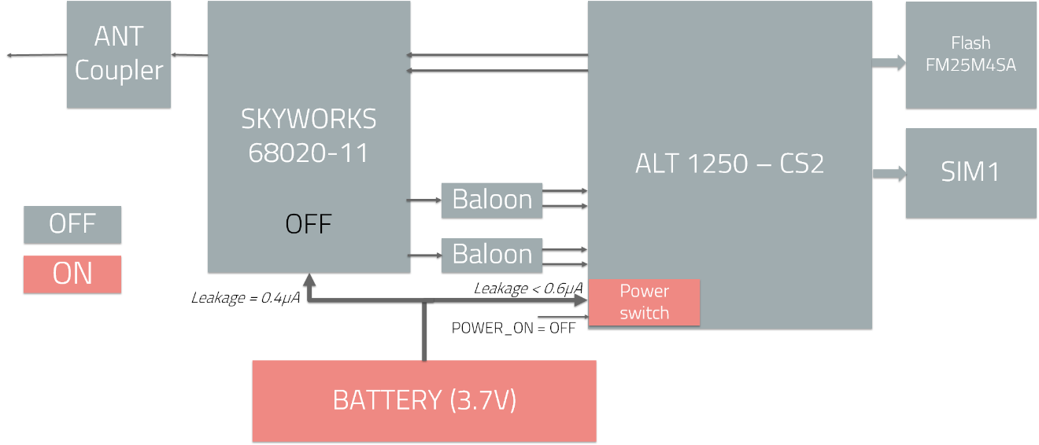
Power Down state

In OFF state, the complete system is OFF. Power consumption is less than 1µA.
Only the POWER_ON pin can wake-up the module.

Deep Hibernate (0,1,2)

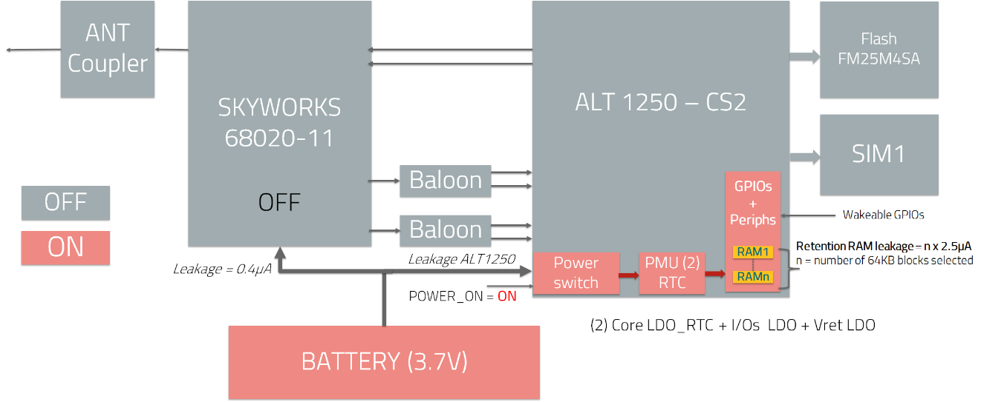
Deep Hibernate Modes

There are 3 Deep Hibernate modes:

- DH0 –Deep hibernation 0
- All digital logic is powered down, memories are not retained, IO are not stored, and the RTC is ‘On’ in this mode.
- Wake-up from DH0 is only possible asserting WAKE_UP, POWER_ON_N or SHUTDOWN pins or by RTC expiration

- A Wakeup event initiates a boot flow. This is the lowest power mode of the system.

- DH1 –Deep hibernation 1
- This mode is like DH0 but adding retention Memory blocks powered ON (up to 1Mbytes of retention RAM by 64Kbytes blocks (1 to 16))
- Like DH0, wake-up is only possible asserting WAKE_UP, POWER_ON_N or SHUTDOWN pins or by a RTC expiration

- A Wakeup event initiates a boot flow. This mode is similar to DH0, however it enables retention memory to store the system state.

- DH2 –Deep hibernation 2
- This mode is like DH1 but with added IOs that can be latched
- Like DH1, wake-up is only possible asserting WAKE_UP, POWER_ON_N or SHUTDOWN pins or by a RTC expiration + digital interfaces or a character received on UART_RX.
In this last case, the first character sent by the host to wake up the chip is lost.

- A Wakeup event initiates a boot flow. This mode is similar to DH1, however it also enables output IOs to latch and wakeup from digital inputs.
Power consumption in DH1 and DH2 depends on the amount of retention memory.

Deep Sleep

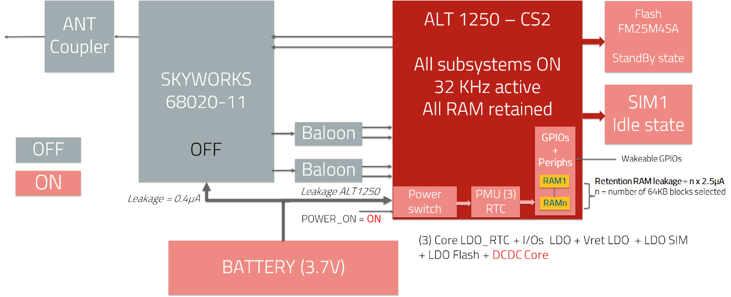
Deep Sleep

Modem is halted, modem SRAM contents retained, and SPI-flash is in standby mode. The 26MHz clock is OFF and 32kHz is active.

Active
There are 3 active states:
- Active Digital: modem processors and engines are active, RF is off.
- Active Receive: Active Digital + RF in receive mode
- Active Transmit: Active Digital + RF in transmit mode

Power save modes characteristics

 | CPU clock | Retention RAM | 26MHz | RTC | I/O | Wake Up mechanism | Consumption
OFF | OFF | OFF | OFF | OFF | OFF | POWER_ON pin | <1µA
DH0 | OFF | OFF | OFF | ON | Not maintained | 2 Chosen GPIOs or WAKEUP pin or RTC | TBD
DH1 | OFF | Yes (n*64KB) | OFF | ON | Not maintained | 2 Chosen GPIOs or WAKEUP pin or RTC | TBD
DH2 | OFF | Yes (n*64KB) | OFF | ON | Maintained | 2 Chosen GPIOs or WAKEUP pin or RTC | TBD
Lite / Shallow Sleep | Halted | Self-refresh | ON | ON | Maintained | 2 Chosen GPIOs or WAKEUP pin or RTC | TBD
Deep Sleep | Halted | Self-refresh | OFF | ON | Maintained | WAKEUP pin  RTC counter | TBD
Active Digital | ON | ON | ON | ON | ON | Any IO | TBD

Cellular Modes
Modem Cat M1 and NB1 may be configured to operate in different low power modes:
- Idle mode (I-DRX) – default mode
- Extended Idle mode (eDRX)
- Power Saving Modes (PSM)

System scenario:
Transition from Active power state to a power-save state depends on system-scenario. Altair defines 5 system-scenario:
- RRC Idle: power-save is applied between paging occasions
- RRC Connected: power-save is applied between C-DRX on-durations
- Switch off/Flight mode (cfun=0/4): power-save is applied between wakeups for MAP apps
- Out-of-coverage (no cell): power-save is applied between network scans.
- PSM: power-save is applied between the expiration of T3324 and T3412.

System power saving mode configuration
Each system scenario can be associated to a radio state: Idle, Connected, No service, PSM.
AT%SET/GETCFG="PW_MODE" AT command is no more supported for 1250 - it was used primarily for internal debug/testing.

In RTOS all power mode parameters are exposed in file 'e:\config\pm'.
Under "conf" section, "max_allowed_pm_mode" parameter controls the lowest PM mode that user application allows the system to enter.
This parameter is passed to MAC/PMP cores, which are responsible for the actual power state.

Possible values of "max_allowed_pm_mode" with different level of power saving, which need to be selected in 'pm' configuration file, are:

ds - Deep sleep
ls - Lite sleep
dh0 - Deep Hibernation 0
dh05 - Deep Hibernation 0.5
dh1 - Deep Hibernation 1
dh2 - Deep Hibernation 2
nap - Nap
none - None
default - Default
phy-only - Phy only

This value may be changed using 'config' command or AT%SETACFG AT command, i.e.

config -s pm.conf.max_allowed_pm_mode dh
at%setacfg=pm.conf.max_allowed_pm_mode,dh

- A reboot is needed to take the new configuration into account.

Another way to configure lowest allowed PM is using the following APIs:

ePowerSaveMode pm_runtime_get_max_sleep_mode (void);
int pm_runtime_set_max_sleep_mode(ePowerSaveMode max_pm_mode);

typedef enum
{
PWR_SAVE_MODE_SW_DEFAULT,
PWR_SAVE_MODE_DISALLOWED = 10,
PWR_SAVE_MODE_ONLY_PHY = 20,
PWR_SAVE_MODE_NAP = 30,
PWR_SAVE_MODE_LS = 40, //shallow
PWR_SAVE_MODE_DS = 50, //deep_sleep
PWR_SAVE_MODE_DH2 = 60,
PWR_SAVE_MODE_DH1 = 70,
PWR_SAVE_MODE_DH05 = 80,
PWR_SAVE_MODE_DH0 = 90,
} ePowerSaveMode;

- This solution doesn’t require a reboot to take the new configuration into account.

HL78xx Hardware design

Schematics DV3

Module’s pins involved in Low Power modes are directly connected to Altair 1250 baseband.

HL78xx
Altair 1250
PMU_POWER_BUTTON
POWER_ON_N
PMU_WAKEUP
WAKEUP

UART1_RX
UART1_RX
UART1
UART1_DTR
UART1_DTR
UART1_DSR
UART1_DSR

DTR signal
When DTR signal is low (active), transition to low power-save states are not possible.

HL78xx Sleep modes

NOTE: On HL78xx modules serie, legacy Sierra’s SLEEP mode is based on Altair’s Deep Sleep mode & New Sierra’s DEEPSLEEP mode is based on Altair’s DH2 mode.
For Software Phase 1 (Dizzy Project) only Sierra’s SLEEP mode is implemented. Sierra’s DEEPSLEEP mode will be implemented later during Software Phase 2.

Altair’s static system power state is set to DH0. Then dynamically, thanks to AT+KSLEEP command and DTR signal state, Altair’s system power state is driven dynamically via a voting mechanism (explained in the annexes of this document).

Low power modes always forbidden.
On HL78xx modules series, low power modes can be forbidden by hardware (DTR & WAKEUP signal) or software (configuration done with AT+KSLEEP AT command).

Low power mode management with AT+KSLEEP command.
Another way to manage power saving modes is to use AT+KSLEEP command. This command configures power saving modes dynamically and save in non-volatile memory the selected configuration.

AT+KSLEEP syntax
AT+KSLEEP=<mngt>[,<level>] with:
<mngt>:
0: Low power modes permission are driven by a hardware signal (DTR or WAKEUP pin) – if the signal is active (low level for DTR, high level for WAKEUP pin), the module does not enter low power modes.
1: Standalone low power modes – the module decides by itself when it enters in low power modes.
2: Low power modes always disabled.

<level>:
Software Phase 1:

0: SLEEP – the module wakes up by a low level on the DTR signal or a high level on the WAKEUP pin; or by reception of a character on UART1 RX (the character is then lost)
1: HIBERNATE – the module wakes up by a high level on the WAKEUP pin
2: LITE_HIBERNATE – the module wakes up by a low level on the DTR signal or a high level on the WAKEUP pin.

Software Phase 2:

0: SLEEP – Ditto software phase 1 (with add of alarm AT+CALA wake-up events)
1: HIBERNATE – Ditto software phase 1 (with add of alarm AT+CALA wake-up events)
2: LITE_HIBERNATE – Ditto software phase 1 (with add of alarm AT+CALA wake-up events)

This parameter is allowed only when <mngt>=0

Hardware management: KSLEEP=0,<level>.

Software Phase 1:

- <level>=0 (SLEEP)
For SLEEP level, power saving transitions are managed by UART1_DTR of HL78xx.
SLEEP state is not allowed when DTR is active (low level).
SLEEP state is allowed when DTR is inactive (high level).

SLEEP mode level is the default one. It is similar to others HL series modules.
In SLEEP mode, MAC & PHY cores are stopped in HALT mode (26MHz clock OFF & 32KHz clock ON), with on chip RAM set in retention mode and QSPI Flash memory in standby mode => Altair’s “deep sleep” mode.
In SLEEP mode, all IOs & RX chars on UART could be used as Wake-up events but first UART RX char is lost. Incoming SMS or IP data reception could be used also as Wake-up events.

- Wake-up time < few ms
- IOs state is retained
- Altair’s MAP voting system: Altair’s “deep sleep” system power state vote

- <level>=1 (HIBERNATE)
For HIBERNATE level, power saving transitions are managed by WAKEUP pin or PSM timer of HL78xx when PSM is enabled (AT+CPSMS=1) or eDRX timer when eDRX is enabled (AT+CEDRXS=1 or 2, …).

HIBERNATE state is not allowed on high level on WAKEUP pin of HL78xx.
HIBERNATE state is allowed on low level on WAKEUP pin of HL78xx.

- PSM mode (AT+KSLEEP=0,1 & AT+CPSMS=1): HIBERNATE PSM mode. Telecom stack implementation based on DH0 System Power state, but execution context of PHY & MAC cores is saved in FLASH memory.

- eDRX mode (AT+KSLEEP=0,1 & AT+CEDRXS=1 or 2, ...): HIBERNATE eDRX mode. Telecom stack implementation based on DH2 System Power state with RAM retention for execution context of PHY & MAC cores or DH1 System Power state (depending on SIM card parameters)

- Wake-up time ~2 s
- IOs state not retained during HIBERNATE PSM mode
- IOs state retained or not during HIBERNATE eDRX mode (depending on SIM card parameters)
- Altair’s MAP voting system: Altair’s “DH0” system power state vote

- <level>=2 (LITE_HIBERNATE)
For LITE_HIBERNATE level, power saving transitions are managed by WAKEUP of HL78xx.
LITE_HIBERNATE state is not allowed when DTR is active (low level).
LITE_HIBERNATE state is allowed when DTR is inactive (high level).

In LITE_HIBERNATE mode, only WAKEUP pin can be used as wake-up event. Incoming SMS, IP data reception or alarm AT+CALA could be used also as Wake-up events.

- Wake-up time ~2 s
- IOs state is retained
- Altair’s MAP voting system: Altair’s “DH2” system power state vote

Software Phase 2:

- <level>=0 (SLEEP) – No change excepted add of alarm AT+CALA wake-up events
- <level>=1 (HIBERNATE) – No change excepted add of alarm AT+CALA wake-up events
- <level>=2 (LITE_HIBERNATE) – To be done

Standalone management: KSLEEP=1.
For this mode, low power modes are allowed.
In this mode, module goes to low power modes as soon as it can. CTS becomes inactive when HL78xx is in SLEEP mode. TBD for HIBERNATE PSM and eDRX modes.
It is woken up by an active DTR, WAKEUP or reception of a character on UART1_RX, this character will be lost.
Active DTR must wake up the module but must not prevent from going in low power modes. A timer must be launched at wake up by DTR and transition to low power modes must be allowed at timeout.
As CTS indicates real SLEEP mode transition, it often flaps.

Sleep mode forbidden: KSLEEP=2
In this mode, all low power modes are always forbidden, whatever states of HL78xx’s DTR is. <level> is not needed.

NVM
Configuration values of +KSLEEP command must be saved in NVM. Last configured values must be set at init.

PSM
Power save level used for PSM must be configured by the command:
AT+KSLEEP=0,<level> with <level> = 1 (HIBERNATE mode)
Or
AT+KSLEEP=1,<level> with <level> = 1 (HIBERNATE mode)

PSM is enabled and customizable by the 3GPP AT command AT+CPSMS (see [R-1] §7.38, 3GPP TS 27.007 version 14.2.0).

If power-save level has not been configured by AT+KSLEEP=0/1,x HL78xx doesn’t go in PSM mode.
AT+KSLEEP=2,x and AT+KSLEEP=0,0 prevent module from going in PSM mode.

eDRX
eDRX is enabled and customizable by the 3GPP AT command AT+CEDRX (see [R-1] §7.40, 3GPP TS 27.007 version 14.2.0).

Power save level used for eDRX must be configured by the command:
AT+KSLEEP=0,<level> with <level> = 1 (HIBERNATE mode)
Or
AT+KSLEEP=1,<level> with <level> = 1 (HIBERNATE mode)

Power OFF
The AT command AT+CPOF power off the module. It asserts DH0 System Power state mode.

It makes the module in hibernation mode as long as WAKEUP pin is not set high.

Power modes summary for Software phase 1

AT+KSLEEP | Altair Mode to be configured | Maximum Altair LPM  and associated current floor | Conditions to enter | IOs State | Wake-up source | Wake-up time
SLEEP | Deep sleep | Deep Sleep 1,2 mA (floor) | DTR if <mgt> = 0  Modem in idle mode | Retained | Any GPIO  SMS/IP data reception | few ms
LITE_HIBERNATE | DH2 | DH2 200 µA (floor) | DTR if <Mgt>=0  Modem in eDRX mode or PSM mode/OFF or no coverage. | Retained | Wake-up PIN  SMS reception  IP data reception  PSM timer  Network search timer | ~2 seconds
HIBERNATE | DH0 | DH0 3 µA (floor) | DTR if <mgt> = 0  Modem in PSM mode/OFF or no coverage | Not Retained | Wake-up PIN  PSM timer when PSM  Network search timer when no coverage | ~2 seconds
HIBERNATE | DH0 | DH1 60 µA (floor) | DTR if <Mgt>=0  Modem in eDRX mode  UICC SIM card allows USIM deactivation | Not Retained | Wake-up PIN  SMS reception  IP data reception | ~2 seconds
HIBERNATE | DH0 | DH2 200 µA (floor) | DTR if <Mgt>=0  Modem in eDRX mode  UICC SIM card doesn't allow USIM deactivation | Retained | Wake-up PIN  SMS reception  IP data reception | ~2 seconds

Power mode transitions diagram (NOT UP TO DATE)

WAKEUP pin or I/Os or teDRX
AT+KSLEEP=0,1 AP+CEDRXS=1 or 2,…
HIBERNATE
DH2 (context previously saved in RAM)

AT+KSLEEP=0,1 AP+CPSMS=1
WAKEUP pin or I/Os or tPSM
HIBERNATE
DH0 (context previously saved in Flash)

AT+KSLEEP=0,0 or AT+KSLEEP=1,0
POWER_ON_N or WAKEUP pins
WAKEUP pin or I/Os or Rx UART
Idle Task
OFF DHO
DEEP SLEEP
DH2 with RAM Ret
RUNNING

BOOT transition in RED

Annexes

Extract of an Altair’s email for the explanation of the Low power modes vote mechanism (Available only in the June 2018 Altair’s software delivery).

“During the operation time of the modem, the software power manager is designed to choose the optimal sleep level that will minimize the power consumption while minimizing the impact on the system functionality.
The implementation for this is done by using multiple logical clients that are communicating with the sleep manager. Each client is allowing or disallowing sleep at specific time while also “voting” for the max sleep level that is suitable for the client at that specific time. When a client allows a “max sleep level”, it means that as far as that specific client concerns, it allows the system to go to the “voted” sleep level or any other sleep level that are considers as lower sleep level. The sleep manager will take all the votes from all clients and will take the minimum level that was reported.
The sleep levels are determined in the order of (from Maximum to Minimum):
DH0->DH1->DH2->DS->LS
For example, Let’s assume the following clients and votes at a specific time.
Clients | Vote
UICC | DH2
PHY | DH1
LTE | DH0
DMA | DH0
RTOS | DH0
In the above table the system will go into DH2 since the UICC client cannot go any lower than DH2.
One note about the UICC client behavior. Since in DH1 we cannot retain the UICC functionality, if the network + sim card configuration is not allowing the UICC to be deactivated, then the client will vote for DH2. If however the network and the SIM configuration allows a deactivation of the sim card, the UICC client will vote for DH0.
This voting mechanism is automatic and is always aiming to use the optimal power state (lowest power). However, as you already know, each level of sleep has its own limitation which are affecting the system functionality.
Please see a general description of the limitation.
State/Limitation | IO’s are retained | Memory retained | wakeup possibilities
DH0 | No | No | Only PMU_Wakeup
DH1 | No | Partially | Only PMU_wakeup
DH2 | Yes  (Currently IO’s are retained but not optimized) | Partially | PMU wakeup  Future support: Multiple IO’s
Deep sleep | Yes  (Currently IO’s are retained but not optimized) | Full | PMU wakeup  Future support: Multiple IO’s
Lite sleep | Yes  (Currently IO’s are retained but not optimized) | Full | PMU wakeup  Future support: Multiple IO’s
Since the sleep manager is not aware of what limitation are acceptable and what are not, we’ve added an API to change the RTOS vote during runtime or in configuration file.
This can be done in the API described below. The API will set the maximum sleep level and will not allow for the sleep manager to any state bellow the voted state.
Considering an example product that is woken up by the PMU_wakeup line and the product does not need the IO’s to be retained. In this case the configured max sleep level in RTOS should be configured to DH0.
In this product, when device will be in PSM it will be able to go to DH0 and when in eDRX it will go to DH1 or DH2 (depending on SIM configuration. DH0 will never be used during eDRX since DH0 is never voted by the modem lower layers during eDRX).
Notice that the actually sleep level might be even lower then DH1 or DH2 as the power manager takes into considerations additional parameters such as the duration of the future sleep interval, available memory, etc. This mean that we might go to DS during eDRX for some cases even if vote was DH0/DH1/DH2.
Another example of a product, is a product that need IO’s to be retained. In this product we should set max sleep level to DH2. In this case system will go no lower the DH2 no matter what is the state of the modem. IO’s retain is currently supported however, for current plans, we only support wakeup by PMU_wakeup.
Please see the following description of the API to control the sleep level and also enable or disable sleep

To control the voted sleep level:
User should add:
#include "pm/pm.h"
/*USER API function to set PM related params*/
ePowerSaveMode pm_runtime_get_max_sleep_mode (void); /*Get current maximum allow sleep level*/
int pm_runtime_set_max_sleep_mode(ePowerSaveMode max_pm_mode); /*set the maximum sleep level – effective immediately*/

RTOS sleep manager (smngr) – for enabling and disabling sleep:
The smngr is the voting api that can be used from RTOS applications to enable or disable sleep (the level is set globally by using the api from the previous section).
Different Drivers and tasks can register (become smngr clients) and effect the smngr (thus allowing or preventing the system from going to sleep).

We differentiated between 2 types of smngr clients:
- The driver/task knows when it wants to prevent and when it allows sleep (we call them sleep manager synchronous dev)
- A driver/task can tell only before going to sleep, if it allows or prevents the system from going to sleep (using a callback which it need to implement - we call them sleep manager asynchronous dev)

The user should decide whether to work synchronously (know when he want to prevent sleep and when he allows) or asynchronously (only when we go to sleep)
Subscribe to the SM by either:

int smngr_register_dev_sync(char *dev_name, u32_t *id);
or:
int smngr_register_dev_async(char *dev_name, void *callback, void *hw, u32_t *id);

For sync device use:
int smngr_dev_busy_set(u32_t id);
int smngr_dev_busy_clr(u32_t id);
To set and clear when you are busy.

For async you should supply a callback (see uart driver code for example)

If we want to check how many times RTOS allowed to go to low power mode and if it was prevented, we can use the CLI command pm-counters.
e.g
>pm-counters
----- PM Counter statistics -----
Time since last run (ms) ---> 10607 ms (10.608 sec)
Allow To Sleep Sent ---> 0
Sleep Disable ---> 0
Sleep one time timer ---> 1056
UART Inactivity time ---> 715
UART Wait for Interrupt ---> 0
FW Don't Allow Sleep ---> 0
General Failure ---> 0
Not Enough Time to Sleep ---> 0
LTE Driver Not ready to Sleep ---> 0
LTE Driver Not register ---> 0
Sleep Manager ---> 341
|---- (1) i2c-0-master ---> 0
|---- (2) i2c-1-master ---> 0
|---- (3) Host-Interface ---> 341
|---- (4) UART1 ---> 0
|---- (5) UART0 ---> 0
“

